***SALESFORCE***

Enter link in your browser to go to Saleforce

<https://artika123.my.salesforce.com/>

Once you click on the above link, the log in screen will populate and ask you to enter your credentials

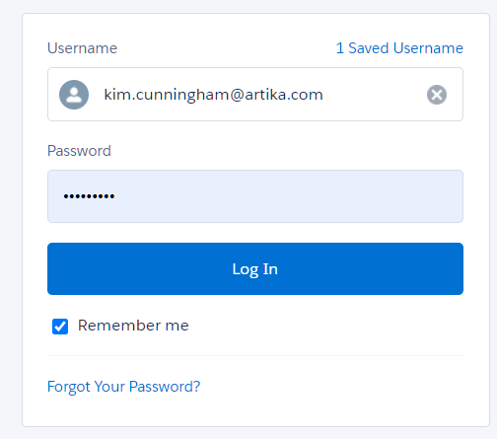

Once you click log in, it will bring you to the home page

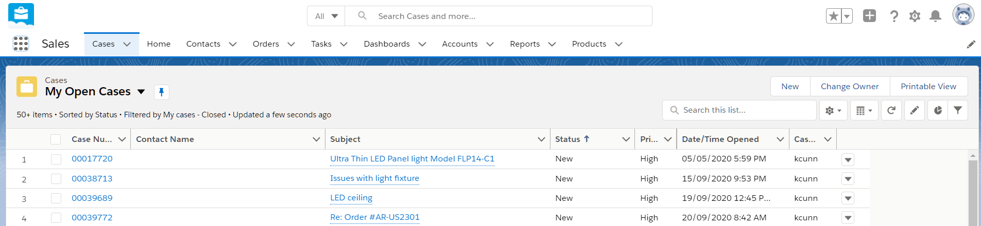

From here you will choose next where you want to go based on what you are doing



If you do not see in your tool bar at the top what you need, click on the 9 dots which appear towards the top far left side



Once you click on the 9 dots, more choices will appear, and you need to select: View All

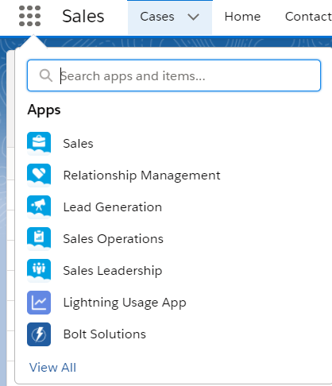

Once you click “ View All”, more selections will appear and you can choose whatever item you are missing.

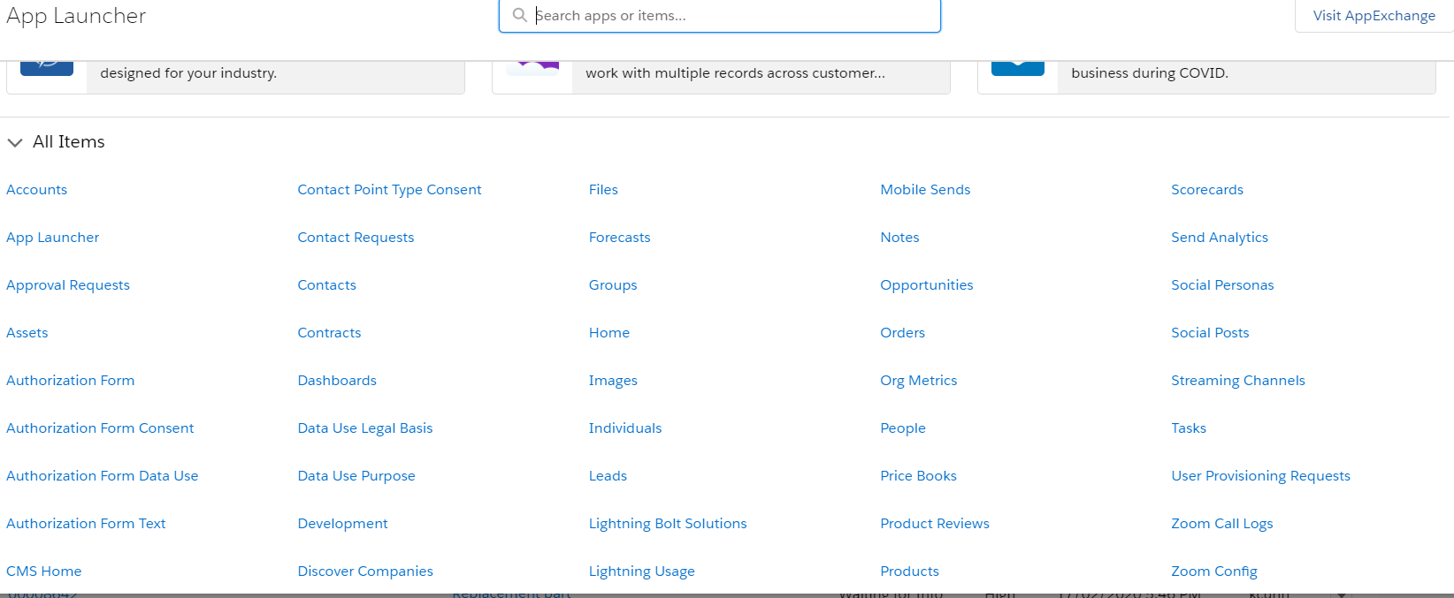

The two hilted areas are search bars. The top one is if you want to search ALL cases, regardless of the status or who they belong to.

The lower, smaller search bar is to only search whichever cases you are in i.e. My open cases or All open cases.

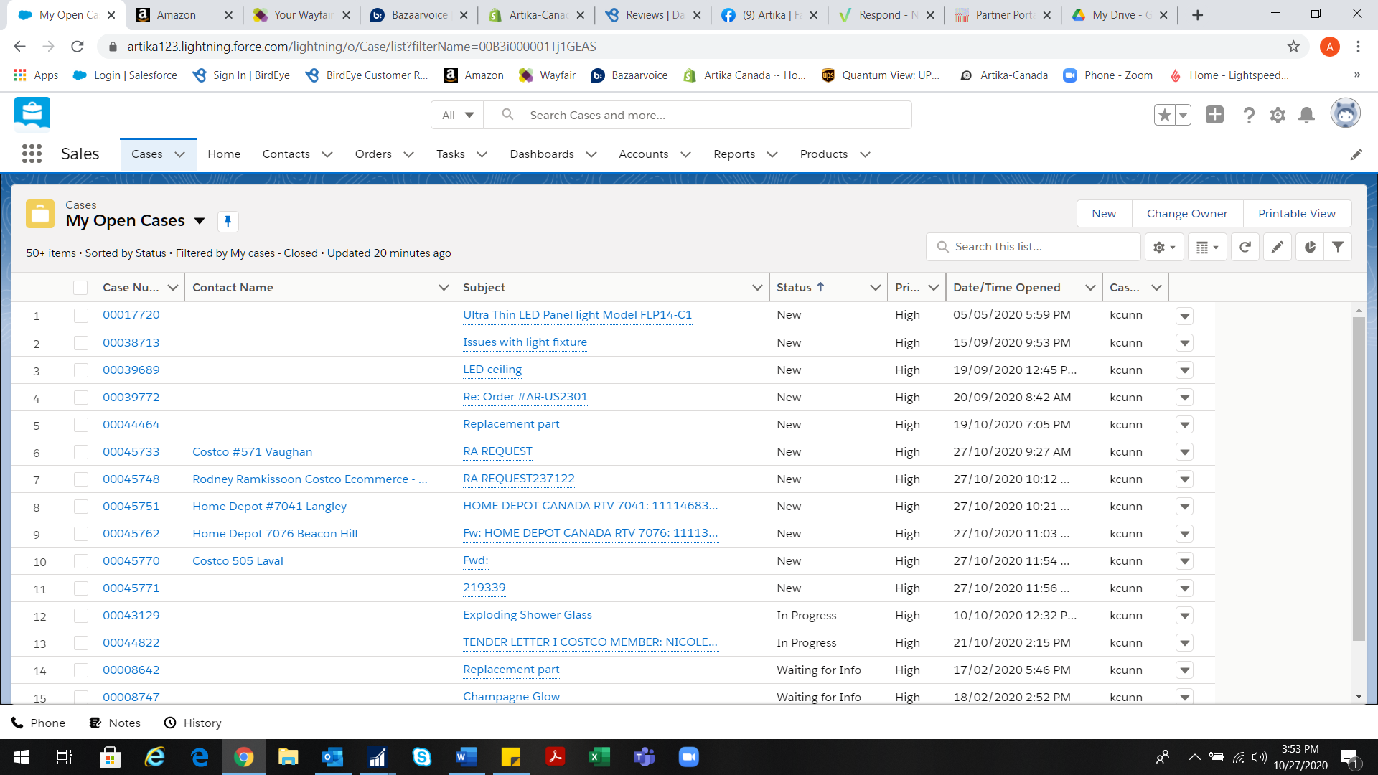

When working on cases, or searching, you need to choose which group of cases you need to be in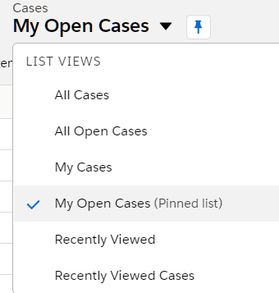

You should only be working in “My Open Cases” or “All Open Cases”. Whichever ones you are in, you can pin it, so it does not switch back if you leave and come back in

***How To Create A New Case***

Click on the drop down just to the right of cases & select “ New Case”

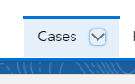

Once you select “ New Case” the following box will appear:

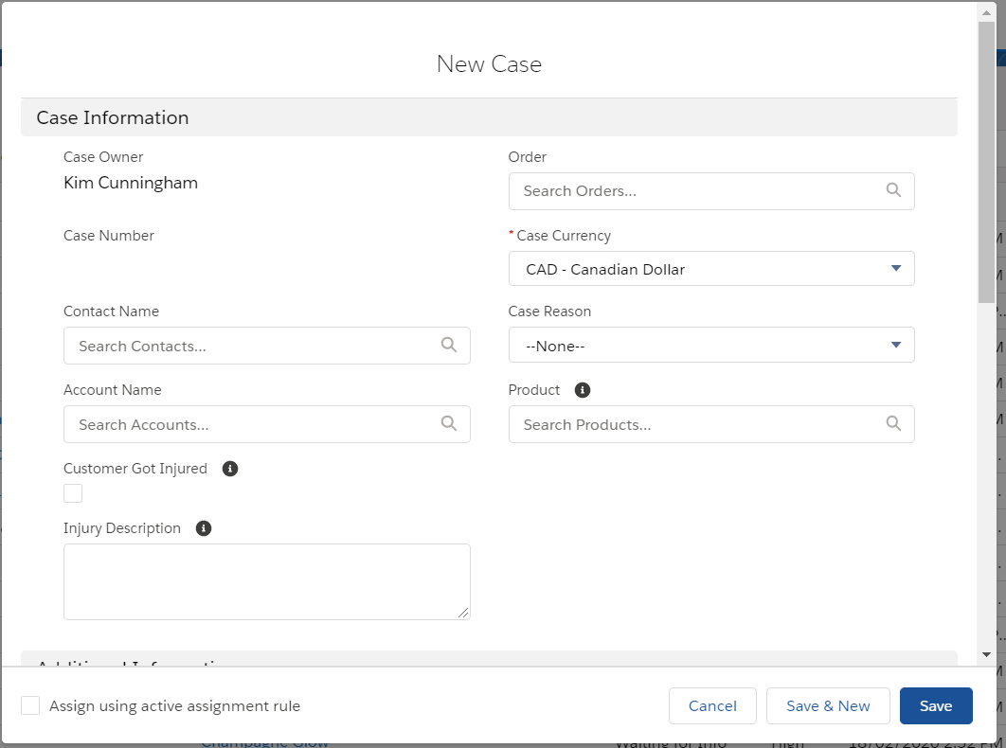

Once in this box, you will need to scroll down to enter all the necessary information.

The mandatory fields are:

* Contact Name
* Account Name
* Type
* Subject
* Description

The click “Save”

If the contact is new for Artika, a secondary box will open once you click “New Contact”

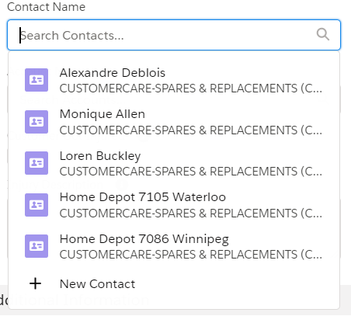

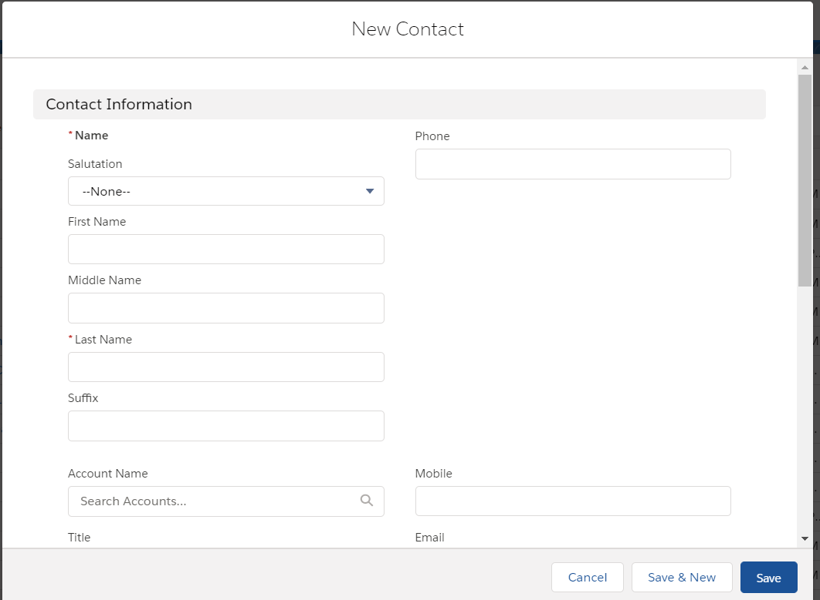

For a new contact, you need to fill out the following mandatory fields:

* First Name
* Last Name
* Account Name
* Phone
* Mobile
* Email
* Language
* Consent to receive marketing emails
* Mailing Address

Then click “Save” and you will be brought back to the main case page.

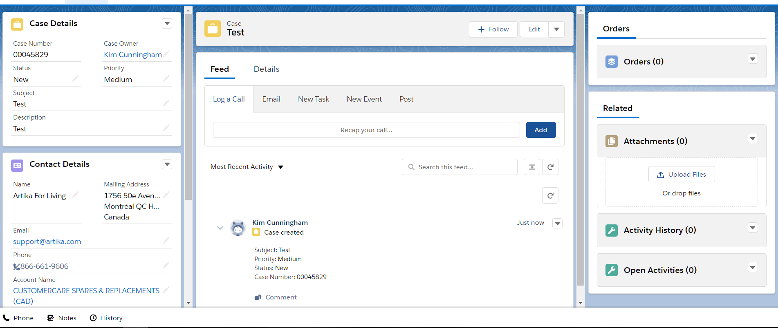

From here you will click the drop down next to “Order” to the far right side, whether you are creating a sales quote (SQ) or a sales order (SO) and select new.

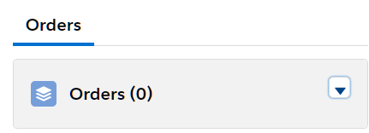

By clicking “New” another box will open up:

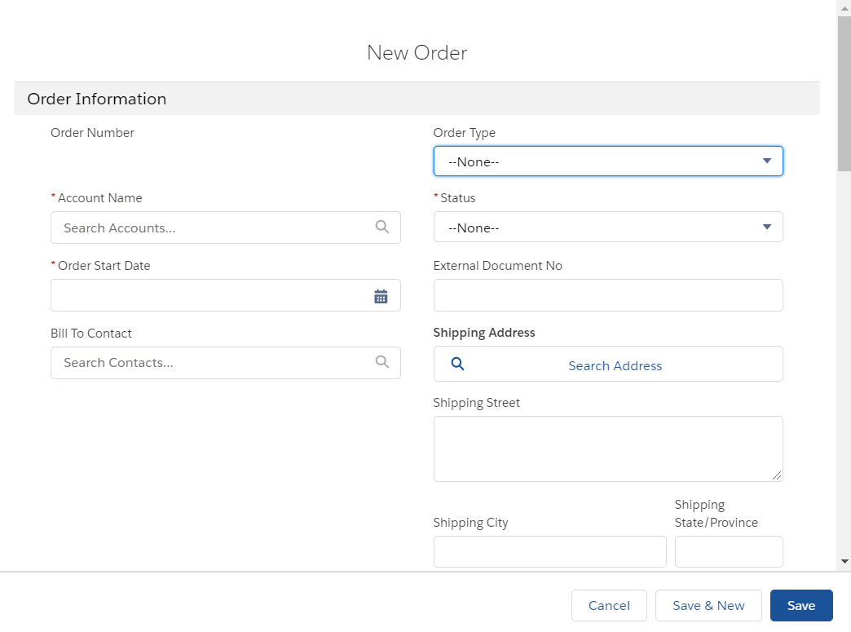

You will need to complete the following mandatory fields:

* Account Name
* Order Start Date
* Bill To Contact
* Order Type
* Status
* External Document No.
* Shipping Address
* Billing Address
* Requested Delivery Date
* Requested By
* Payment Code
* Tax Area Code
* Confirmation Email

You will ONLY check the little box under If SO if you are creating a sales order. If you are creating a SQ then you leave it blank.

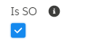 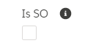

The you click “Save”

When you click, save you will be brought back to the main case page where you will need to enter back into the order to create the order. You now will need to click on the order number to the far right:

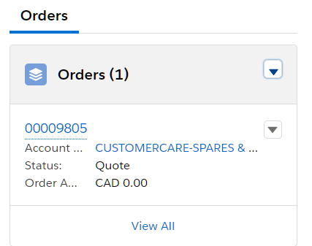

Once you click the order number underlined in blue, you will be brought to the next page where you will wait approximately 1-3 minutes for your SQ or SO to generate.

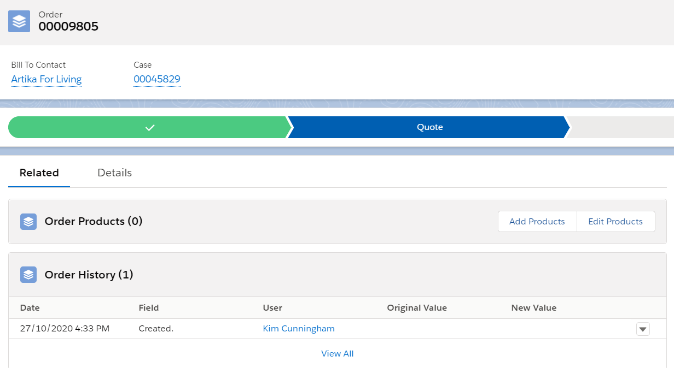

Select Details and scroll down to find the NAV Order URL. Once the SQ or So# is generated you will click on it and it will bring you to NAV.

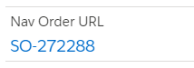

The following box will appear, click Open Microsoft Dynamics Nav Client

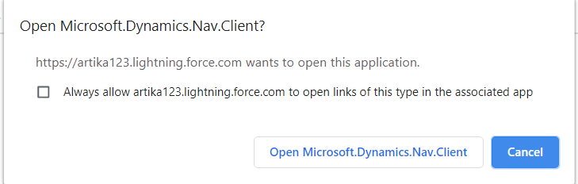

Once you click this then you will be brought direct into NAV to complete the order.

